**Основи тестування мобільних додатків**

**Рівень 1**

Bug 1.

**Title:**

On the main page the slider images switcher overlap the text

Environment:

* Device: MI 11T Pro. MIUI Global 13.0.7
* Android 12 (SKQ1. 211006.001)
* Browser: Chrome 109.0.5414.117

Priority: low

**STR:**

1 Open the main page https://www.kmlvm.com.ua/

2 Check the results

**AR:** the slider images switcher overlap the text

**ER:** the slider images switcher should not overlap the text

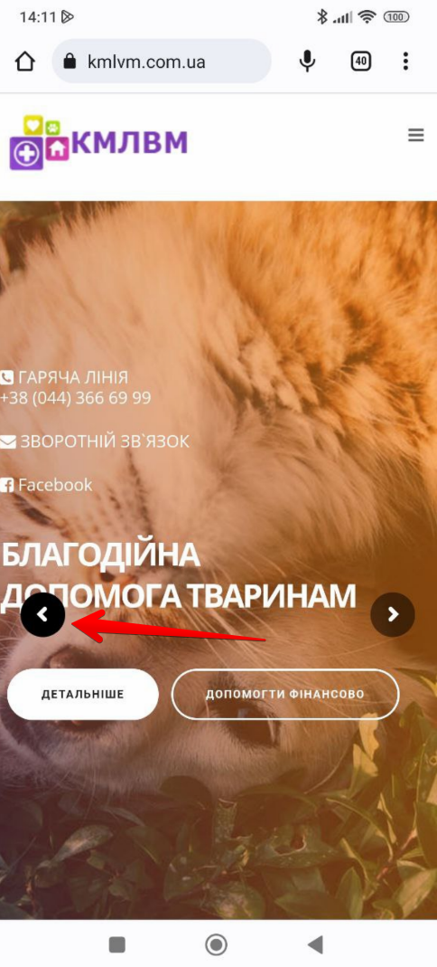

Bug 2.

**Title:**

In the footer under the "Благодійність" section, none of the images are clickable

Environment:

* Device: MI 11T Pro. MIUI Global 13.0.7
* Android 12 (SKQ1. 211006.001)
* Browser: Chrome 109.0.5414.117

Priority: mid

**STR:**

1 Open the main page https://www.kmlvm.com.ua/

2 Scroll down the page to the footer until you reach "Благодійність" section

3 Press on the VISA, Happy Radio, and PrivatBank images

4 Press on the Благодійність text above the specified images

**AR:** none of the specified elements lead to the donation page after clicking on them

**ER:** every element, including both the specified text and images should lead to the donation section

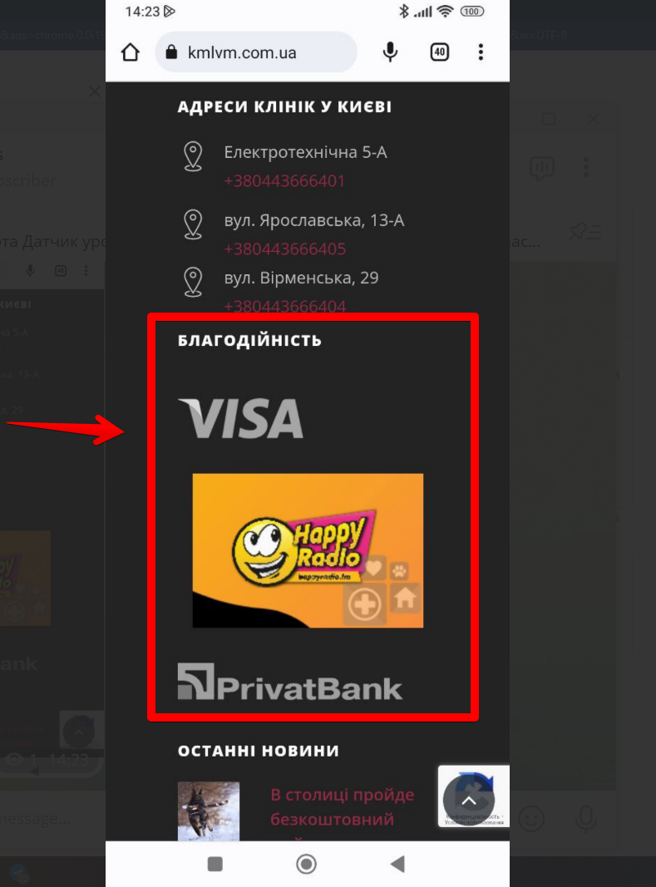

Bug 3.

**Title:**

The schedule page from the burger menu tab is not accessible

Environment:

* Device: MI 11T Pro. MIUI Global 13.0.7
* Android 12 (SKQ1. 211006.001)
* Browser: Chrome 109.0.5414.117

Priority: high

**STR:**

1 Open the main page <https://www.kmlvm.com.ua/>

2 Press the Burger menu button on the top left side of the page

3 Press “Графік прийому громадян” and check the results

**AR:** The page does not exist

**ER:** After attempting to visit the “Графік прийому громадян” page the user should access the selected page

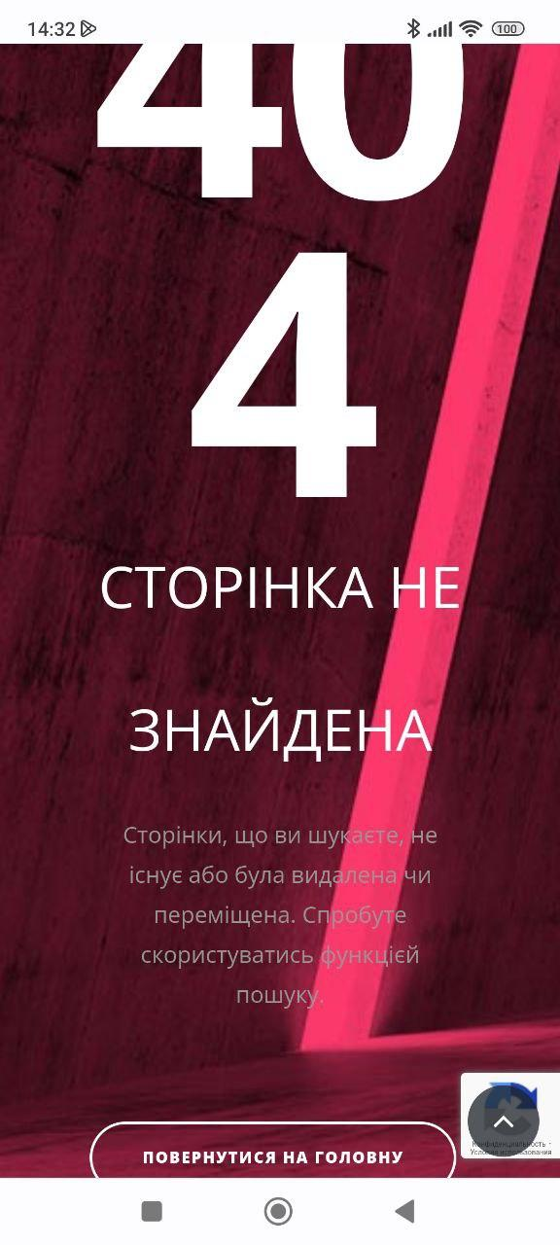

Bug 4.

**Title:**

On the vacancies page, the list alignment is broken

Environment:

* Device: MI 11T Pro. MIUI Global 13.0.7
* Android 12 (SKQ1. 211006.001)
* Browser: Chrome 109.0.5414.117

Priority: low

**STR:**

1 Visit <https://www.kmlvm.com.ua/vakansii/>

2 Scroll down the page until you reach the mentioned list (check the screenshot below)

**AR:** The third list point is not aligned

**ER:** All the list points should be aligned

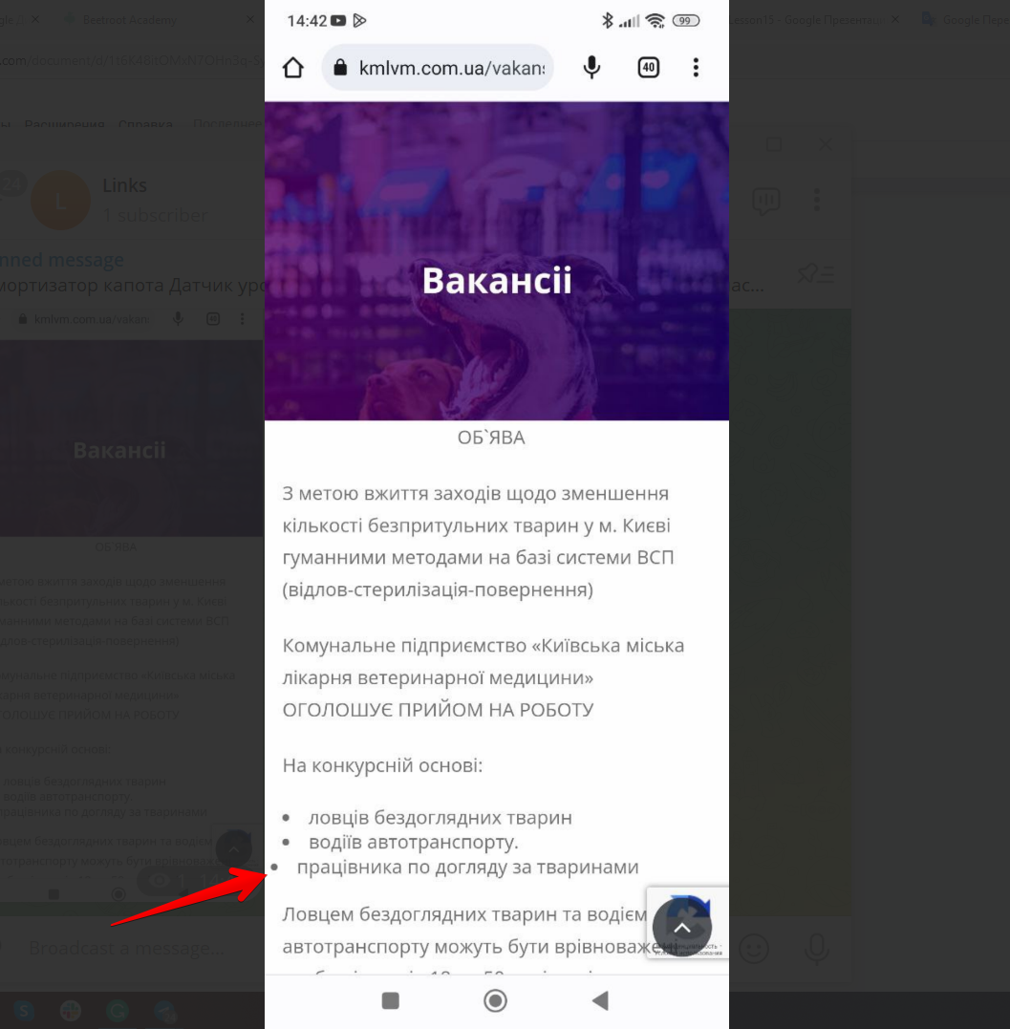

Bug 5.

**Title:**

The pets' names are not fully visible on the "require adoption" page

Environment:

* Device: MI 11T Pro. MIUI Global 13.0.7
* Android 12 (SKQ1. 211006.001)
* Browser: Chrome 109.0.5414.117

Priority: mid

**STR:**

1 Visit <https://www.kmlvm.com.ua/dopomoga-tvarynam/shukayut-domivku/>

2 Scroll down the page until you reach the pets’ list

3 Pay attention to the pets’ names

**AR:** The names are not fully visible

**ER:** The names should be fully visible

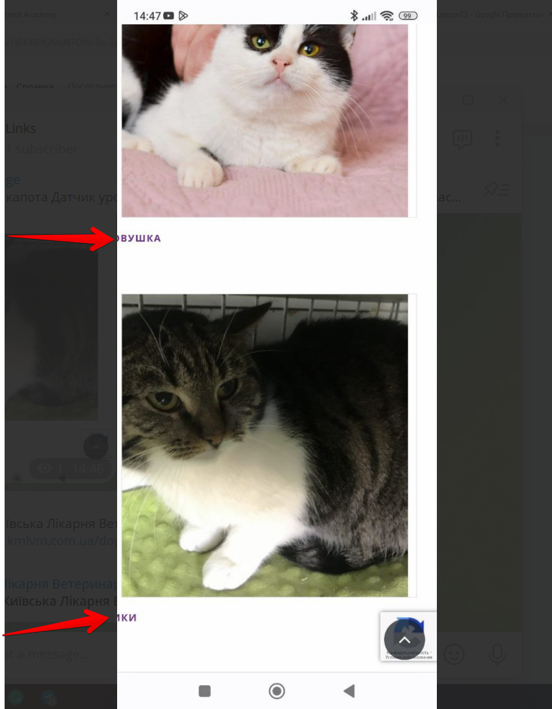

**Рівень 2.**

**I've spent over 2 hours attempting to troubleshoot the issue related to HAXM without any success.**

**To ensure the latest HAXM version is used I've downloaded it from github directly according to the both emulator and HAXM recommendations:**

[**https://github.com/intel/haxm/releases**](https://github.com/intel/haxm/releases)

